|  |
| --- |
| **HDFS**      ASSIGNMENT 2.1  Submitted By  PRAVEEN PHILIP SANTHOSH |

1. Created a file word called word-count1.txt on the desktop.
2. Open the file in the VI editor using ‘ vim’ command.

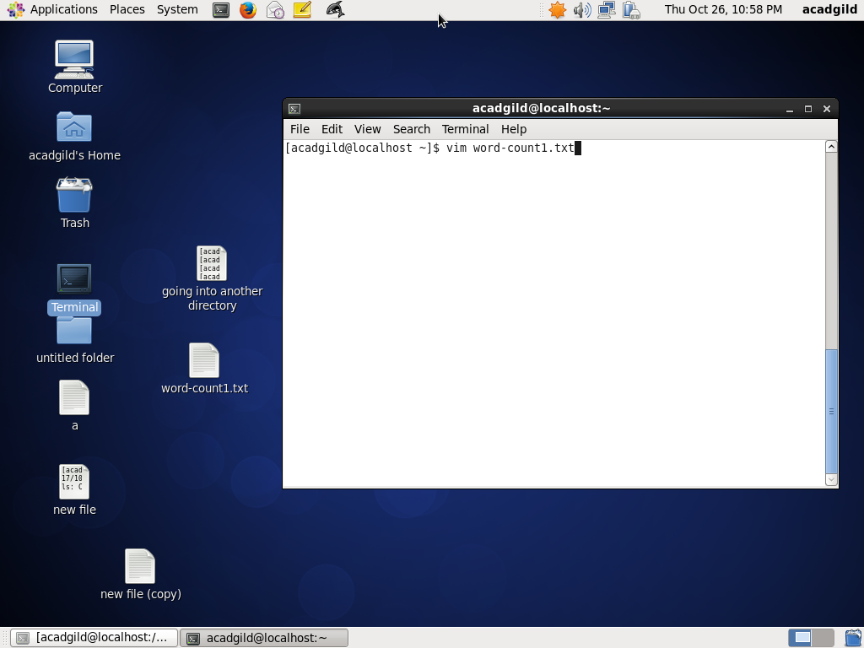

1. Press enter and open the VI editor and then press “i “and then when INSERT appears type some sentence into the file.

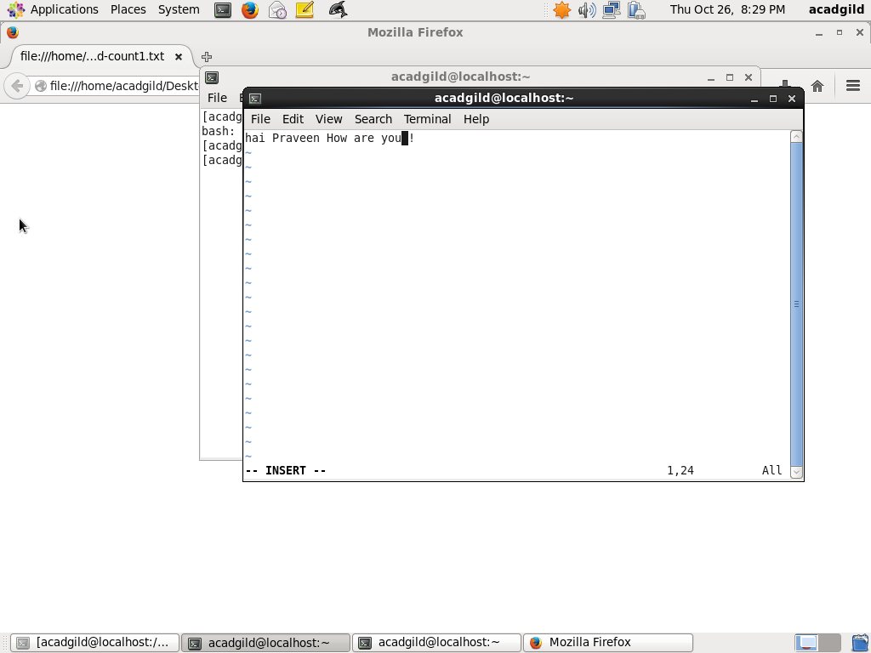

1. Type :qw word-count1.txt (ie- name of the word file) into the terminal and press enter ,it quits after saving the changes

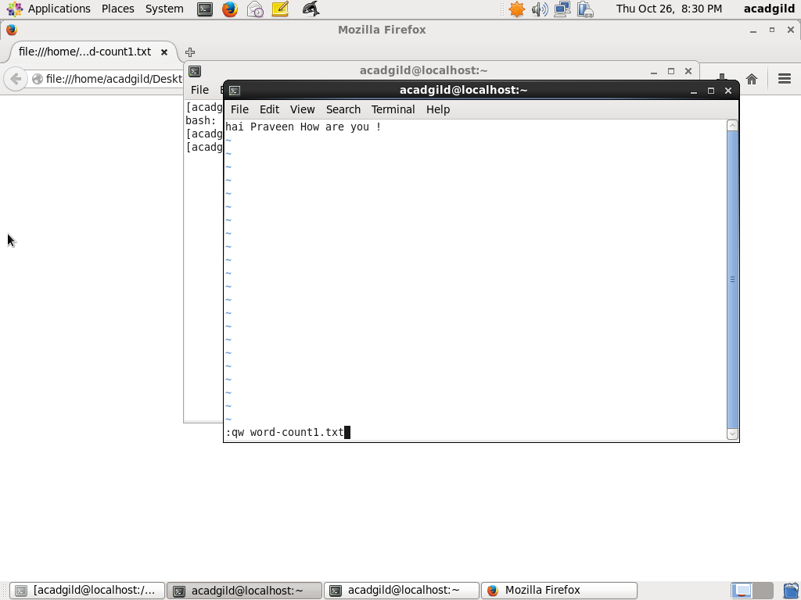

1. Use the Cat command to display the contents of the file

